PUBLIkacje
1) J. Jurczak, M. J. Chmielewski, P. Dydio, D. Lichosyt, F. Ulatowski, T. Zieliński, “Benzopyrrole derivatives as effective anion receptors in highly competitive solvents” Pure Appl. Chem. 2011, 83, 1543-1554.
Brak abstractu
2) M. J. Chmielewski, “A short, multigram synthesis of 1,8-diaminocarbazole” Synthesis 2010, 3067-3069.
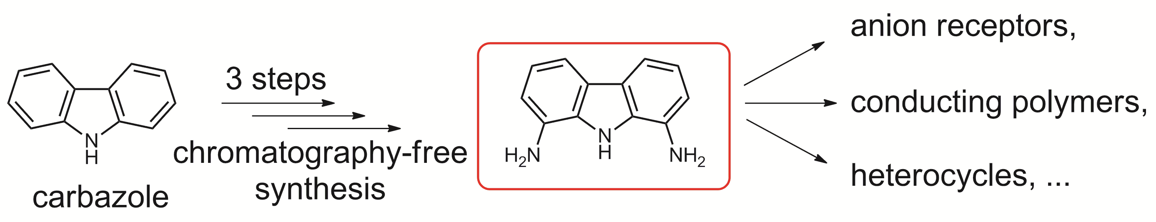
3) A. Brown, K. Mullen, J. Ryu, M. Chmielewski, S. Santos, V. Felix, A. Thompson, J. Warren, S. Pascu, P. Beer, “Interlocked Host Anion Recognition by an Indolocarbazole-Containing [2]Rotaxane” J. Am. Chem. Soc. 2009, 131, 4937–4952.
4) L. Zhao, K. M. Mullen, M. J. Chmielewski, A. Brown, N. Bampos, P. D. Beer, J. J. Davis, “Anion templated assembly of an indolocarbazole containing pseudorotaxane on beads and silica nanoparticles” New J. Chem. 2009, 760-768.
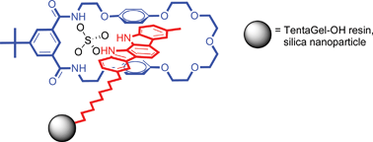
5) L. Zhao, J. J. Davis, K. M. Mullen, M. J. Chmielewski, R. M. J. Jacobs, A. Brown, P. D. Beer, “Anion Templated Formation of Pseudorotaxane and Rotaxane Monolayers on Gold from Neutral Components” Langmuir 2009, 25, 2935-2940.
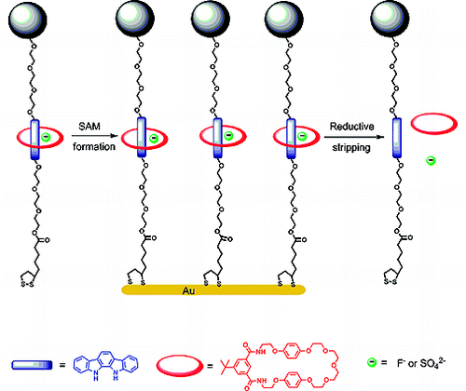
6) A. Tarajko, A. Michota, M. J. Chmielewski, J. Bukowska, M. Skompska, “Electrochemical and spectroscopic characterization of poly(1,8-diaminocarbazole). Part II. Electrochemical, in-situ Vis/NIR and Raman studies of redox reaction of PDACz in protic and aprotic media” Electrochimica Acta 2009, 54, 4751-4759.
Brak abstraktu
7) A. Tarajko, H. Cybulski, M. J. Chmielewski, J. Bukowska, M. Skompska, “Electrochemical and spectroscopic characterization of poly(1,8-diaminocarbazole). Part I. Electropolymerization and determination of the polymer structure” Electrochimica Acta 2009, 54, 4743-4750.
Brak abstraktu
8) M. J. Chmielewski, J. J. Davis, P. D. Beer, “Interlocked host rotaxane and catenane structures for sensing charged guest species via optical and electrochemical methodologies” Org. Biomol. Chem. 2009, 7, 415-424.
9) M. J. Chmielewski, P. D. Beer, “Strategic anion templation for the assembly of interlocked structures”, in: Organic Nanostructures, J. L. Atwood and J. W. Steed (eds.), Wiley-VCH, 2008.
10) M. J. Chmielewski, L. Zhao, A. Brown, D. Curiel, M. R. Sambrook, A. L. Thompson, S. M. Santos, V. Felix, J. J. Davis, P. D. Beer, “Sulfate anion templation of a neutral pseudorotaxane assembly using an indolocarbazole threading component” Chem. Commun. 2008, 3154–3156.
11) S. R. Bayly, T. M. Gray, M. J. Chmielewski, J. J. Davis, P. D. Beer, “Anion templated surface assembly of a redox-active sensory rotaxane” Chem. Commun. 2007, 2234–2236.
12) M. J. Chmielewski, T. Zieliński, J. Jurczak, “Synthesis, structure, and complexing properties of macrocyclic receptors for anions” Pure Appl. Chem. 2007, 79, 1087–1096.
13) M. Skompska, M. J. Chmielewski, A. Tarajko, “Poly(1,8-diaminocarbazole)-a Novel Conducting Polymer for Sensor Application” Electrochem. Comm. 2007, 9, 540-544.
Brak abstraktu
14) M. J. Chmielewski, M. Pawlicki, N. Sprutta, L. Szterenberg, L. Latos-Grażyński, “Cadmium(II) and Zinc(II) Complexes of S-Confused Thiaporphyrin” Inorg. Chem. 2006, 45, 8664-8671.
15) E. Paśniczek, M. J. Chmielewski, P. Grzegorzewski, A. Kulesza, J. Jurczak, “An Improved Method for the Synthesis of Macrocyclic Benzodiamides and Dibenzotetraamides” Polish J. Chem. 2006, 80, 899-906.
Brak abstraktu
16) M. J. Chmielewski, J. Jurczak, “Anion Binding versus Intramolecular Hydrogen Bonding in Neutral Macrocyclic Amides” Chem. Eur. J. 2006, 12, 7652-7667.
17) M. J. Chmielewski, J. Jurczak, “Anion Recognition by Neutral Macrocyclic Amides” Chem. Eur. J. 2005, 11, 6080-6094.
18) M. J. Chmielewski, Ł. Dobrzycki, J. Jurczak, K. Woźniak, “Unusual anion-anion self-assembly inside a macrocycle-defined channel in the crystal lattice” Cryst. Growth Des. 2005, 5, 1339-1341.
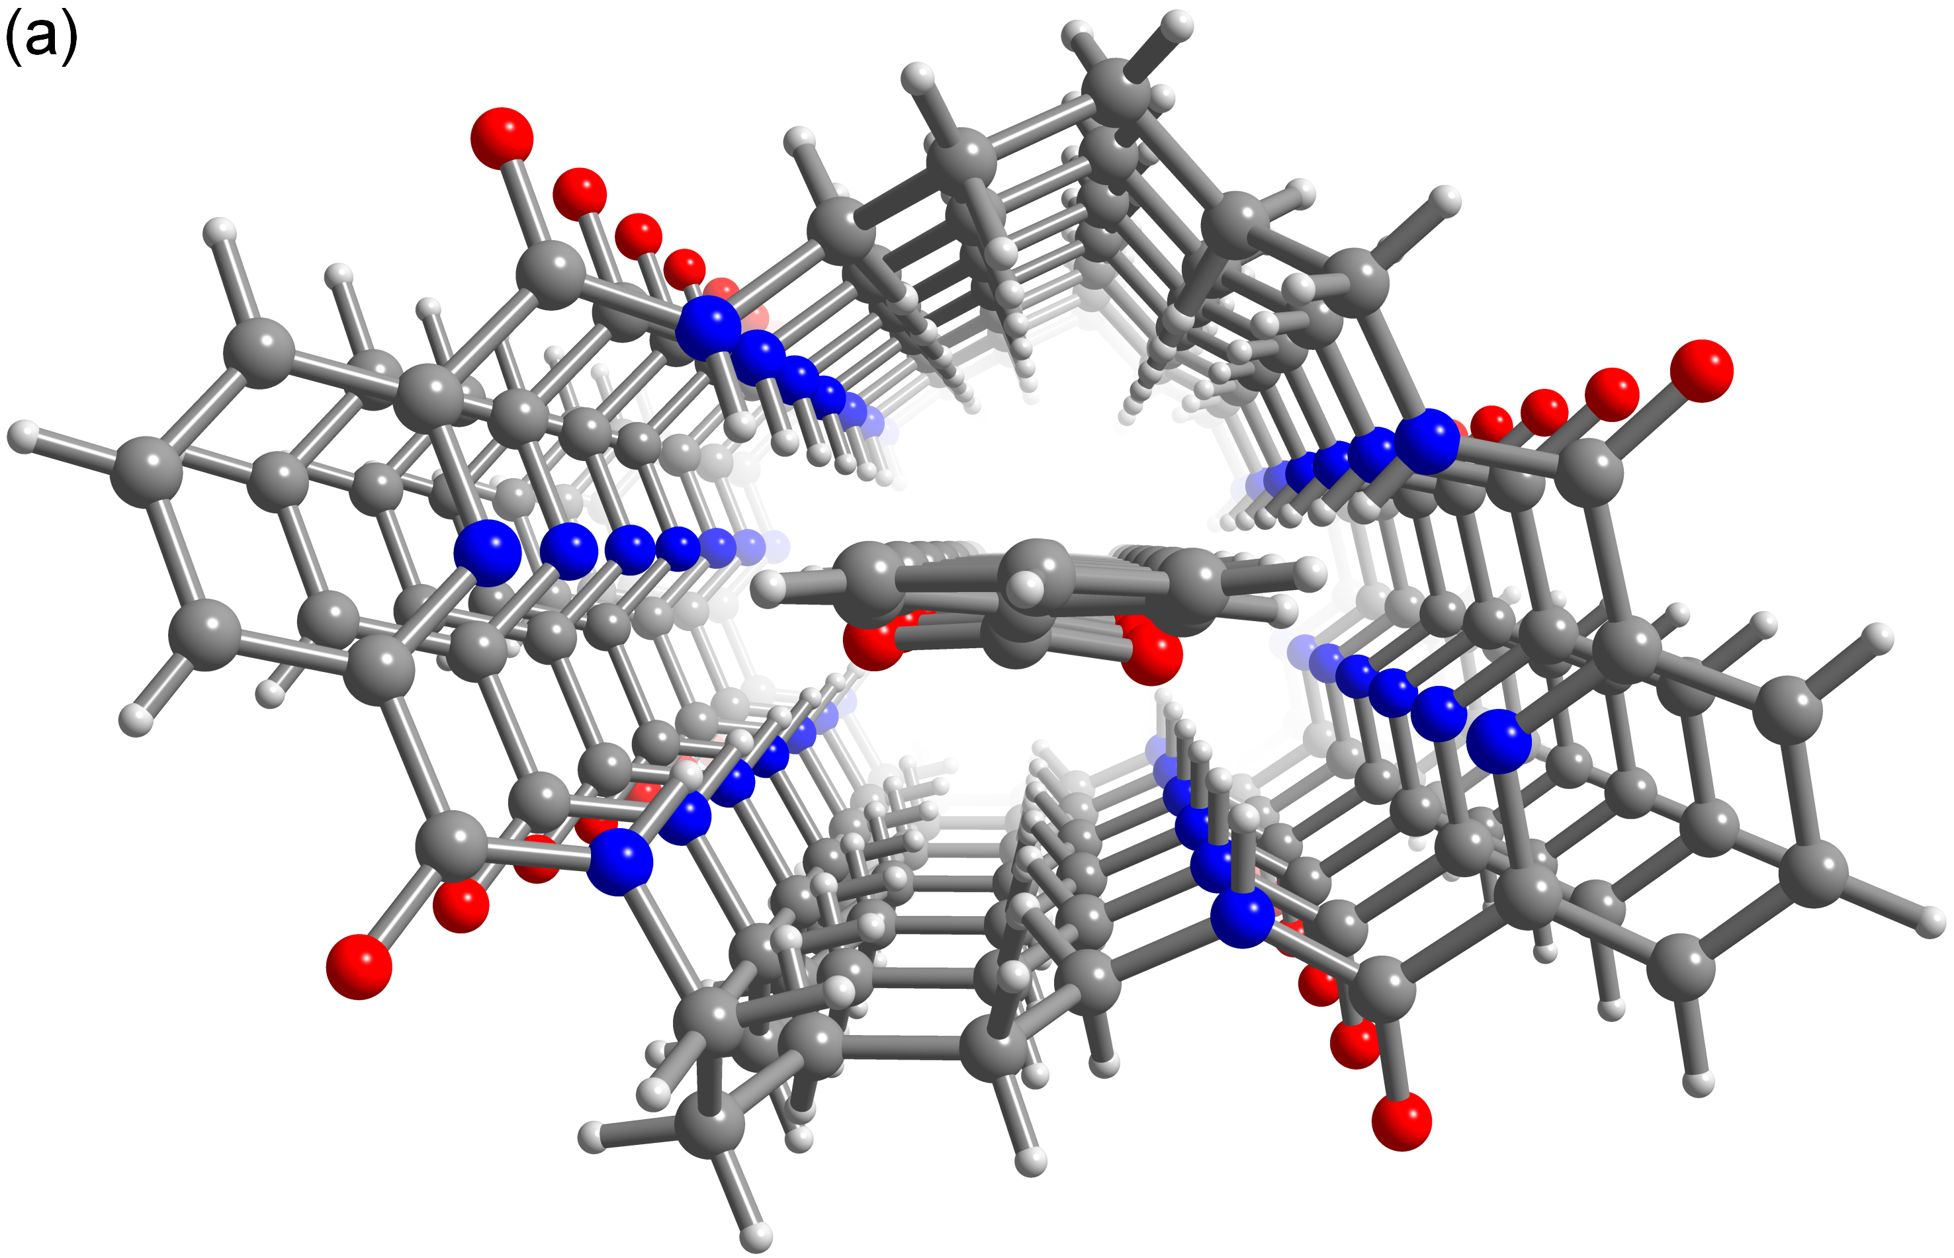
19) M. J. Chmielewski, J. Jurczak, “A hybrid macrocycle containing benzene and pyridine subunits is a better anion receptor than both its homoaromatic congeners” Tetrahedron Lett. 2005, 46, 3085-3088.
20) M. J. Chmielewski, A. Szumna, J. Jurczak, “Anion induced conformational switch of a macrocyclic amide receptor” Tetrahedron Lett. 2004, 45, 8699-8703.
21) M. J. Chmielewski, J. Jurczak, “Size complementarity in anion recognition by neutral macrocyclic tetraamides” Tetrahedron Lett. 2004, 45, 6007-6010.
22) M. J. Chmielewski, M. Charon, J. Jurczak, “1,8-Diamino-3,6-dichlorocarbazole – a promising building block for anion receptors” Org. Lett. 2004, 6, 3501-3504.

